Start-Up Surge 2024 Report

Academic Year: 2023-24 SEM-II
Name of the Event:“Start-Up Surge 2024”
Date & Time of the Event: 13thApril2024, 9 AM to 6 PM.
Targeted Audience: Participants from all over India.
Venue: International Institute of Information Technology, Hinjawadi, Pune.
Event Organizer: Dr. Jyoti Surve
Event Coordinator: Prof. Prashant Mandale, Prof. Deepti Chaudhari and Prof. Bhagyashri Thorat
Number of Participants: 26Teams (65 Students) Selected out of 50Teams
Activity Description in Nutshell:
Event Overview:

On 13th April 2024, Startup Surge 2024 was held at the International Institute of Information Technology (I2IT) Pune. This premier entrepreneurial platform brought together creators, inventors, innovators, and visionaries from across India to present their pioneering concepts before a panel of esteemed judges, offering prospects for potential investment. The event was inspired by renowned entrepreneurial showcases like Shark Tank, creating an electrifying atmosphere that encouraged competition and collaboration among the brightest young minds.

Startup Surge 2024 exclusively invited undergraduate students from AICTE-approved institutions across India, ensuring a diverse and talented pool of participants. The event aimed to nurture creativity, foster entrepreneurship, and facilitate avenues for investment in burgeoning startups. By providing a rigorous evaluation process and expert guidance, Startup Surge sought to cultivate a thriving ecosystem where entrepreneurial spirit flourishes and transformative innovations receive the support and resources they need to succeed.

Throughout the day, participants had the opportunity to pitch their innovative business propositions, engage with mentors, and receive feedback from experienced industry professionals. The event not only showcased cutting-edge ideas but also emphasized the importance of networking, mentorship, and real-world entrepreneurial experiences.

In addition to the competition, attendees had the chance to meet and interact with notable personalities from the entrepreneurial world, including winners from Shark Tank Season 1, such as Ms. Rakhi Pal and Mr. Saurabh Mangurlkar, Co-Founders at Event Beep. These interactions provided valuable insights and inspiration, encouraging participants to pursue their entrepreneurial aspirations with renewed vigor.

Event Objectives:

The objectives of Startup Surge 2024 were multifaceted:

Foster Innovation: Encourage the cultivation andexpression of innovative ideas among aspiring entrepreneurs,fostering an environment conducive to creative thinking andproblem-solving.

2. Facilitate Networking: Provide a platform for buddingentrepreneurs to connect with established industry leaders,mentors, and fellow innovators, fostering valuablerelationships and collaborations.

3. Enable Access to Investment: Offer opportunities forstart-ups to secure crucial funding and investment, facilitatingthe growth and scalability of promising ventures.

4. Educate and Inspire: Educate and inspire young studententrepreneurs through exposure to real-worldentrepreneurship experiences, success stories, andmentorship, empowering them with the knowledge andmotivation to pursue their entrepreneurial aspirations.

5. Promote Holistic Development: Support the holisticdevelopment of students by equipping them withentrepreneurial skills, leadership qualities, and businessacumen, enabling them to thrive in both professional andpersonal capacities.

6. Catalyzes Socio-economic Impact: Encourage thedevelopment of start-ups with a focus on creating positivesocial and economic impact, fostering sustainable solutions toaddress pressing global challenges.

Domain Areas:

Startup ideas were solicited across diverse sectors, including but not limited to:

AI Start-ups

Employee Management Solutions

Workspace Engagement and Employee Benefits

AI in Agriculture

Innovations in Cloud and GPU Services

Consumer Electronics

B2B SaaS Technology

B2B High-Tech Products

Event Highlights:

Startup Surge 2024 saw participation from 50 teams across India, with the top 26 teams selected to present their innovative business propositions. The event showcased a variety of solutions, from AI applications in agriculture to cutting-edge consumer electronics.

Inauguration and Keynote Speakers:

The inauguration of Startup Surge 2024 was presided over by prominent personalities:

Ms. Rakhi Pal, Co-Founder at Event Beep

Mr. Saurabh Mangurlkar, Co-Founder at Event Beep

Anup Tapadia, Founder of TouchMagix Media Pvt Ltd.

Shridhan Rokade, Founder & CEO of Expert Cloud Consulting

Sagnik Ghosh, Co-Founder and CEO at WorqHat

Competition and Winners:

The competition was intense, with each team given 15 minutes to present their work in front of the jury. The final round involved presentations in front of all investors. The top three winning teams received funding support of up to ₹1 Lakh each.

TEAM Retrievo

Team Leader: Om Thakkar

Team Members: Yuvraj Singh, Sukhmani

College: Marathwada Mitra Mandal's College of Engineering, Pune

Investor Support: Mr. Sagnik Ghosh, CEO and Co-founder at WorqHat

TEAM Impact Connect

Team Leader: Vansh Kanakia

Team Members: Prajwal Lalpotu, Abhishek Fadke

College: International Institute of Information Technology, Pune

Investor Support: Mr. Shridhan Rokade, Founder and CEO of Expert Cloud Consulting

TEAM RanwaraKukkut Palan

Team Leader: Amardeep Landge

Team Members: Sudesh Sanjay Gurav

College: RajgadDnyanpeeth Technical Campus Polytechnic, Dhangawadi

Investor Support: Mr. Anup Tapadia, CEO of TouchMagix Media Pvt. Ltd.

Prize Distribution and Valedictory Function:
The prestigious prize distribution and valedictory function were held on the same day. Awards were given by the following dignitaries:
- Mr. Sagnik Ghosh to Team Retrievo
- Mr. Shridhan Rokade to Team Impact Connect
- Mr. Anup Tapadia to Team RanwaraKukkut Palan (given by Mr. Shridhan Rokade on behalf of Mr. Anup Tapadia).
Dr. Jyoti Surve, initiated the program, welcoming the guests followed by Principal Dr. Vaishali Patilappreciating the hard work of the participants and organizers. The prize distribution ceremony followed, celebrating the innovative spirit and dedication of the young entrepreneurs.
Start-Up Surge 2024 was a resounding success, providing a platform for young innovators to showcase their ideas, connect with industry leaders, and secure potential investments. The event not only highlighted the creativity and entrepreneurial spirit of India's youth but also promised to foster future growth and innovation. As participants return to their respective institutions, they carry with them the knowledge, experience, and motivation to continue their entrepreneurial journeys and make a positive impact on society.

Event Photos:
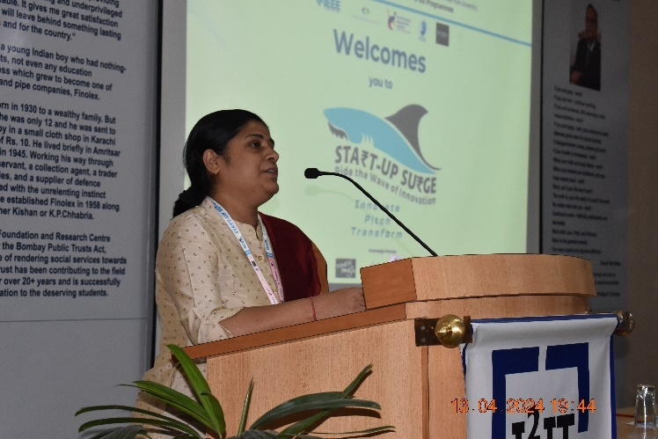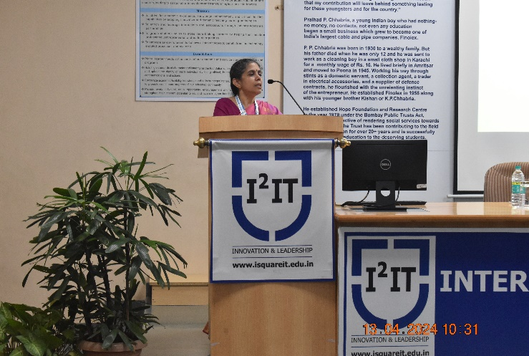
Vote of Thanks by Dr. Jyoti SurveCoordinatorIntroductory talk by Dr. Vaishali PatilPrincipal
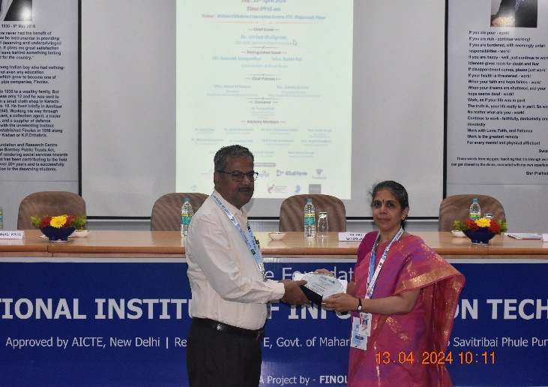
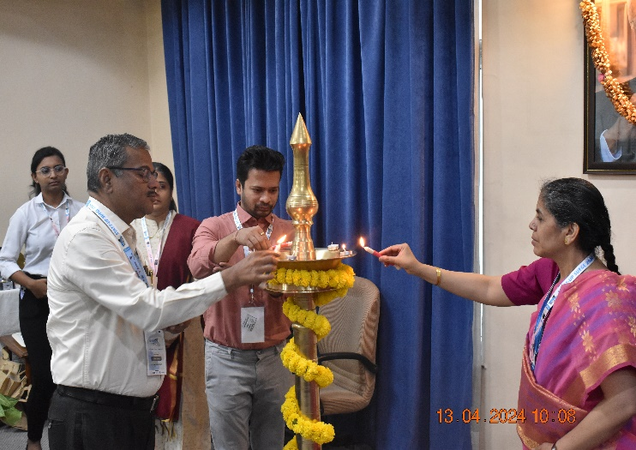
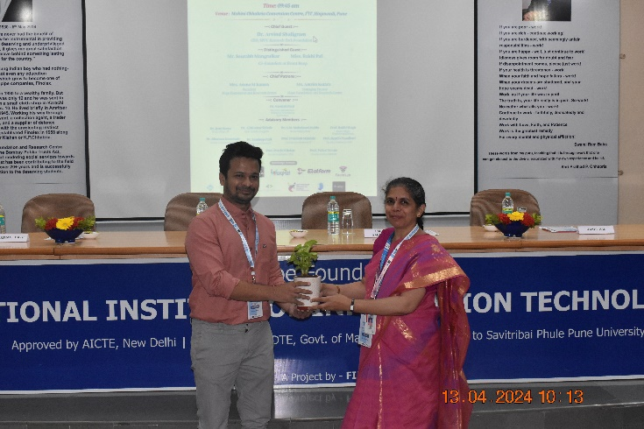
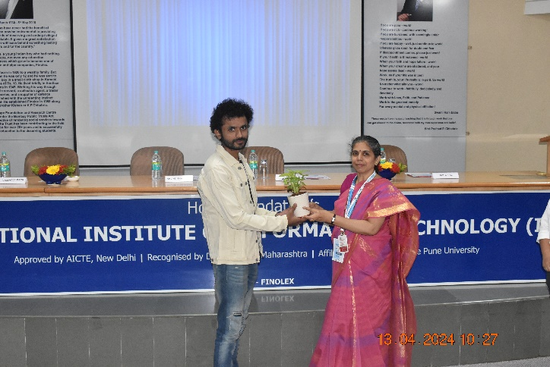
Lightlighting the I2IT Vidya Jyoti Felicitation of GuestsDr. Arvind Shaligram
Felicitation of Dignitaries ___ andMr. Saurabh Mangrulkar
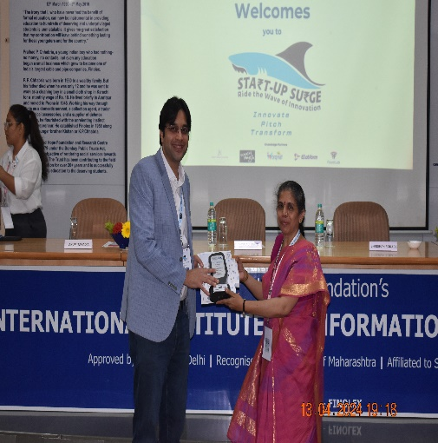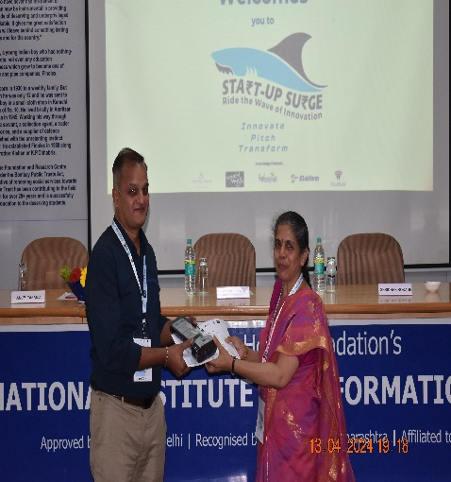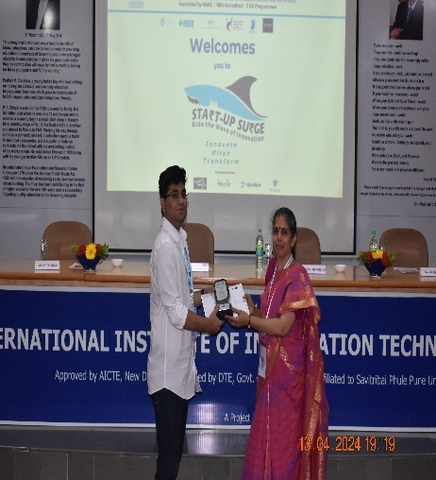
Felicitation of InvestorsMr. Anup Tapadia, Mr.Shridhan Rokade and Mr.Sagnik Ghosh
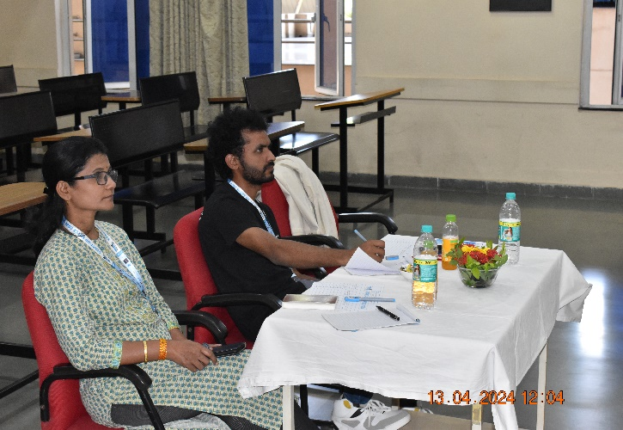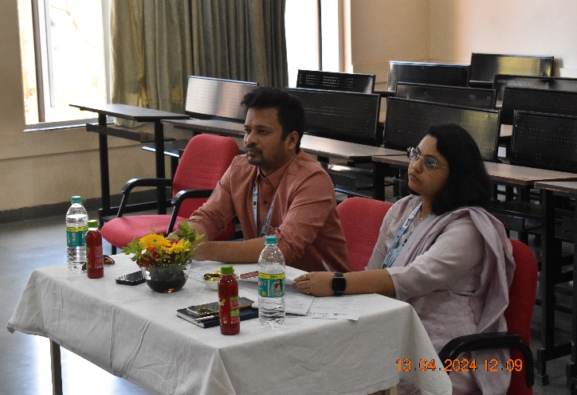
Jury members Panel 1 for Round 1Jury members Panel 2for Round 1

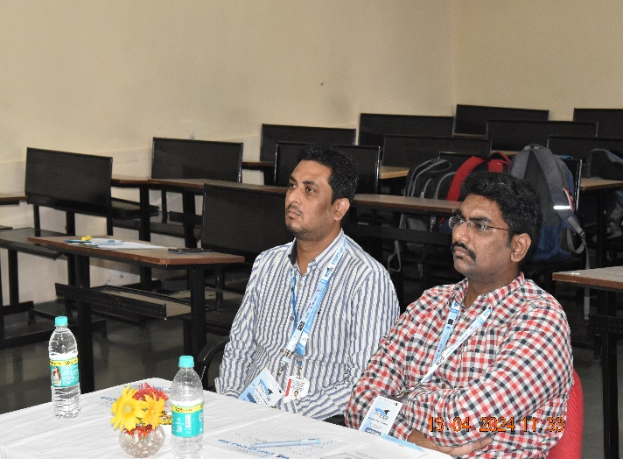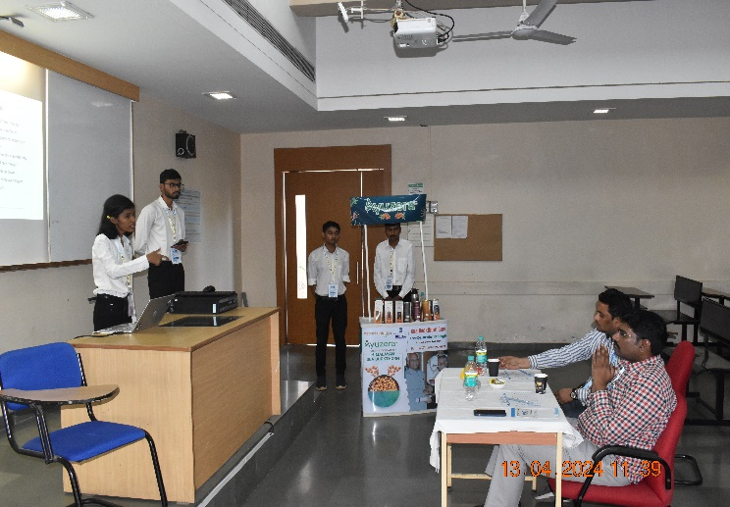
Jury members Panel 3for Round 1 Participant Team Pitching Ideas to Jury
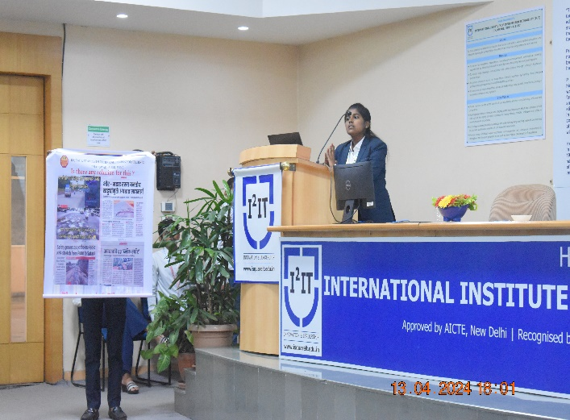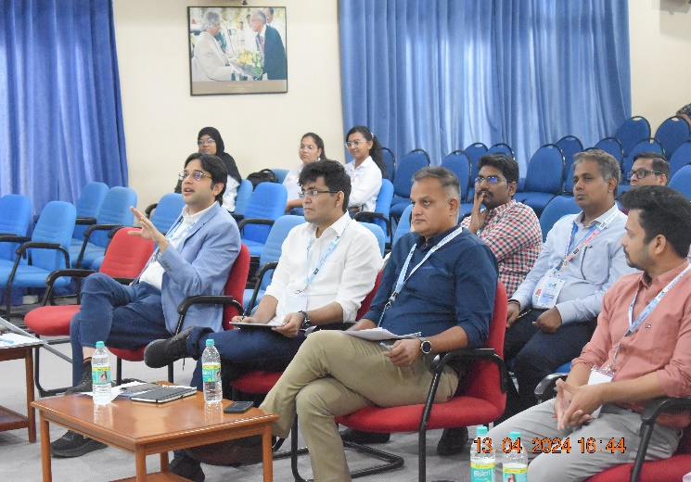
Participant Team Pitching Ideas to Jury Jury Panel for Round 2

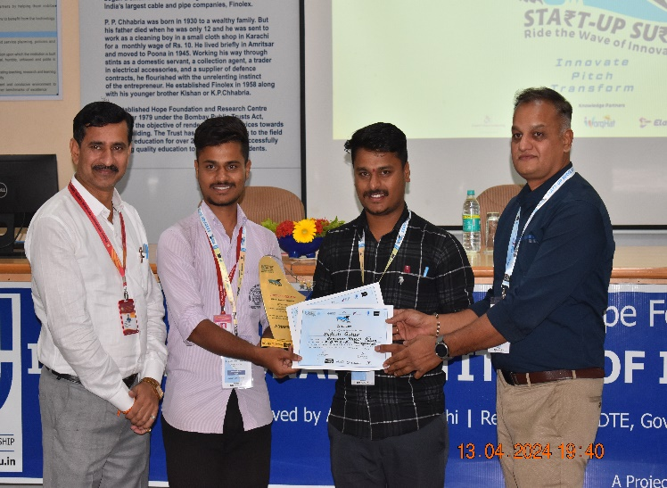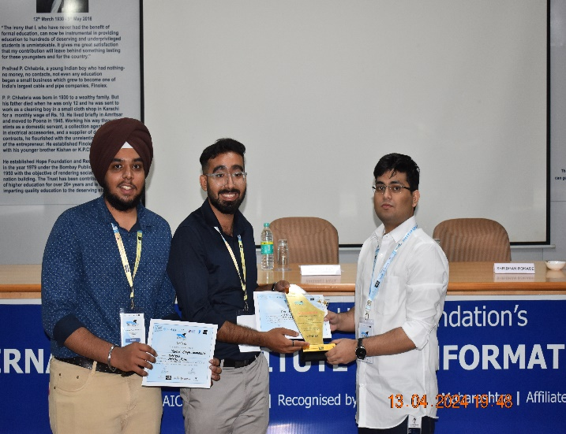
Winner Team Winner Team
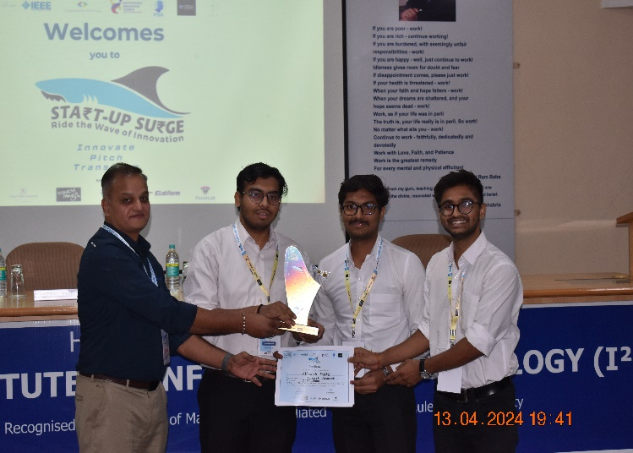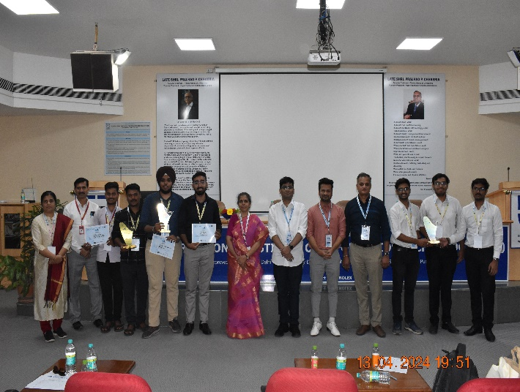
Winner Team Group Photo of Winner Teams
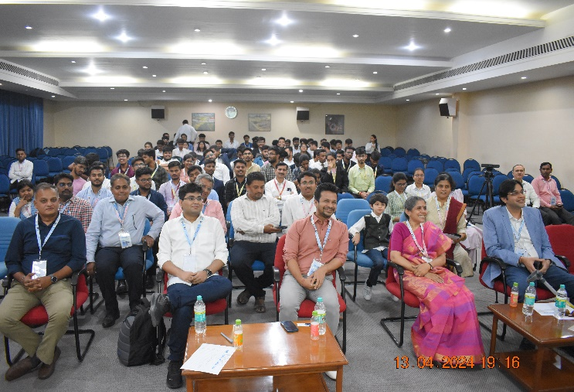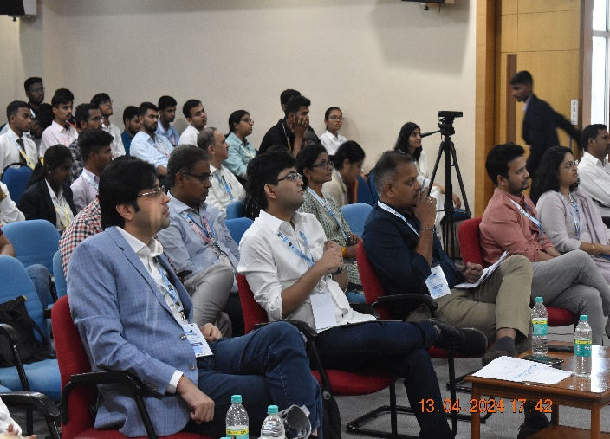
Final round of Pitching
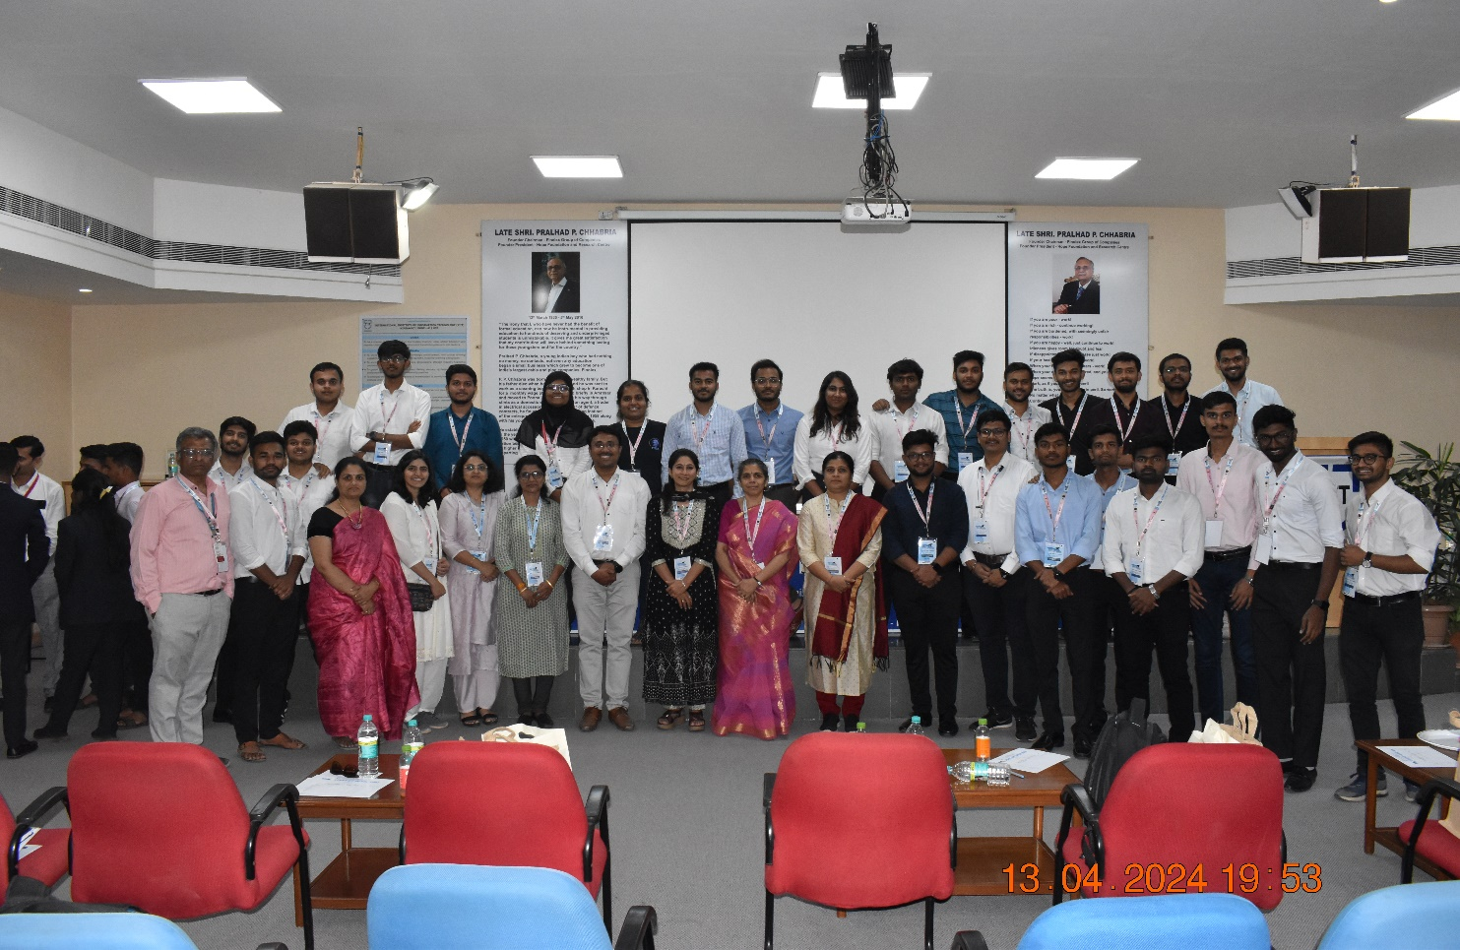
Organizing Team Members

Dr. Jyoti Surve Dr. Vaishali Patil
Event Organizer Principal

